# Energy Budgets: Understanding the heat budget of montane butterflies

## [Link to the visualization](https://huckley.shinyapps.io/ButterflyAdvanced/)

## [Link to TrEnCh-Ed](https://trench-ed.github.io/#)

## Objectives

* Describe how the properties of organisms influence how they experience their environments.
* Identify the difference between heat and temperature.
* Identify the different heat flows between organisms and their environment.
* Describe how an energy budget is constructed and use it to estimate an organism’s body temperature.
* Explain how organisms use behavior to maintain homeostasis.

## Core concepts -- *BioCore*

* Physiology: Evolution
* Ecology & Evolutionary Biology: Evolution
* Physiology: Information Flow
* Physiology: Structure Function
* Ecology & Evolutionary Biology: Structure Function
* Physiology: Transformations of Energy and Matter
* Physiology: Systems

## Instructions

First, read through the Energy Budgets introduction in the visualization. This will give you the required background information for these exercises.

### Radiation: Reflection and Absorption

1. The paired visual and thermal (dark=cool) images below depict a seastar on a bed of mussels (which are its prey).   
  
 A. How are the temperatures of the   
 seastars and the mussels different?

B. Why do you think they have different body temperatures despite being in the same environment?

C. How do you think their different temperatures influence the interactions between seastars and mussels?

### Heat and Temperature

1. Given these definitions, consider a pot of boiling water and a large iceberg floating in the ocean. 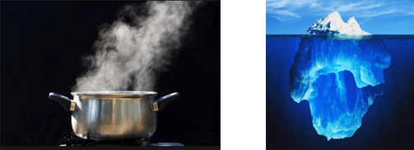

1. Which of these bodies of water contains the most heat? Highlight your selection and explain in part B.

Pot of Boiling Water Large Iceberg

1. Briefly explain your reasoning to your choice above.

2. The distinction between temperature and heat is also central to understanding firewalking-- the act of walking barefoot over a bed on hot embers of stones. Think about the difference between temperature and heat to explain why you think firewalking is possible. (But we’re not recommending you try it out!)

### Forms of heat flow

1. Do you think losing heat via evaporation is more effective on dry or humid days? Explain your answer. Hint: think about the concept of diffusion.

2. First consider the pictures below (here lighter colors depict warmer temperatures, °F).

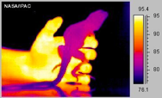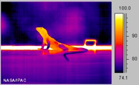

1. What observations do you have about the two images below?

Left image:

Right image:

1. Use the heat flows above to describe how and why the body temperatures of the lizard varies between the two pictures.

3. Next we will consider Emperor penguins and their adaptations to survive the harsh Antarctic climate. For each adaptation below, indicate the heat flow being altered (CONVECTION, CONDUCTION, RADIATION) and provide a brief explanation of how the adaptation works.

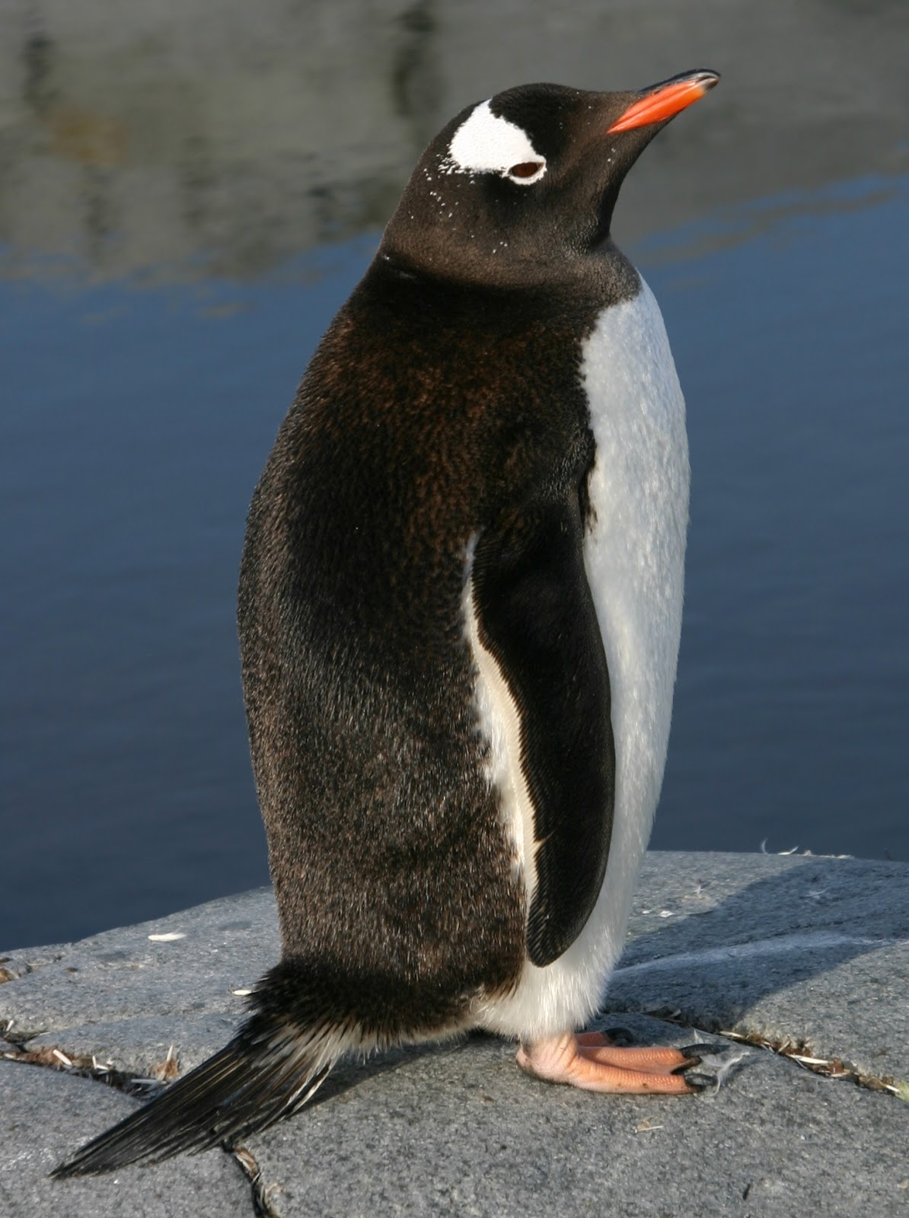

1. Penguins have a relatively large body size.

Heat Flow:

Explanation:

1. Penguins have a short, stiff tail.

Heat Flow: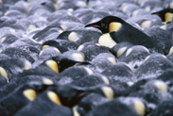

Explanation:

1. Penguins huddle together.

Heat Flow:

Explanation:

1. Penguin feet and flippers have a heat-exchange arterial system whereby warm blood leaving the core flows past cold blood returning from the appendages.

Heat Flow:

Explanation:

1. Penguins have dark colored feathers on their back.

Heat Flow:

Explanation: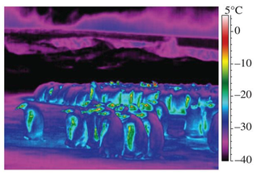

1. Briefly interpret this thermal image of isolated and huddling penguins (*T*air =−21.0°C, from McCafferty et al. 2013. Biology Letters).

### Visualization

1. Using the visualization, answer the following questions:

1. How does the estimated butterfly temperature (operative) vary from air temperature (environmental)?
2. At what time of day is the difference between the temperatures the greatest?
3. Briefly hypothesize why these differences occur.

2. Choose a weather, morphological, and terrain variable to change and describe how the difference between estimated body and air temperature changes. Record observations after each change.

1. Weather
2. Morphology
3. Terrain

3. Return to the variable changes you made in question 2. Now look at the “analysis” section to explore how the variable change influences heat flows. How does the solar radiative heat flux, thermal radiative flux, and convective heat flux change when you change the variable?

|  |  |  |  |
| --- | --- | --- | --- |
| **Variable Change** | **Solar radiative heat flux (mW)** | **Thermal radiative flux (mW)** | **Convective heat flux (mW)** |
| Weather: |  |  |  |
| Morphology: |  |  |  |
| Terrain: |  |  |  |

Briefly explain why you think the heat fluxes are changing.

### Homeostasis and the influence of behavior

1. Behavior is often an easy way for organisms to adjust their heat exchanges with the environment. Consider the following examples and photos of animal behavior. List and briefly discuss what forms of energy exchange (CONVECTION, CONDUCTION, RADIATION) the behavior is likely to alter.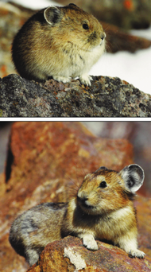

1. An insect “stilts” up on the tip of its legs.
2. A pika curls up in a ball and minimizes its contact with a rock.
3. Alternative, the pika spreads its body out over the rock and spreads its ears.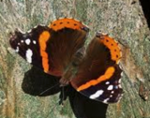
4. A butterfly orients its dark wings relative to the sun.

### Synthetic question

1. Consider a squirrel (an endotherm) that is producing heat to maintain a constant body temperature (homeostasis) in a cold environment. How much heat the squirrel produces can be assessed by measuring its metabolic rate.

1. Apply what you’ve learned about energy budgets to draw a line predicting how the squirrel’s metabolic rate will respond to increasing wind speed if it is maintaining homeostasis.
2. Assume that the first line you drew was for a shady environment. Draw a second (dashed) line corresponding to your prediction for a squirrel in a sunny environment.

